### **An Easter Snow Globe Sliceform**

Easter and snow should not be mentioned in the same sentence. However, this year our weather has been really crazy and we have been experiencing unseasonable weather. I just put away my snow boots and hopefully, I will not have to retrieve them again until next winter.  
  
I made an egg-shaped snow globe with an Easter egg hunt scene. I made the children to look like my son and daughter wearing their favorite clothes when they were little. Look at the PDF below to see what the scenery looks like...it is hard to get a good photo of the inside of the egg.

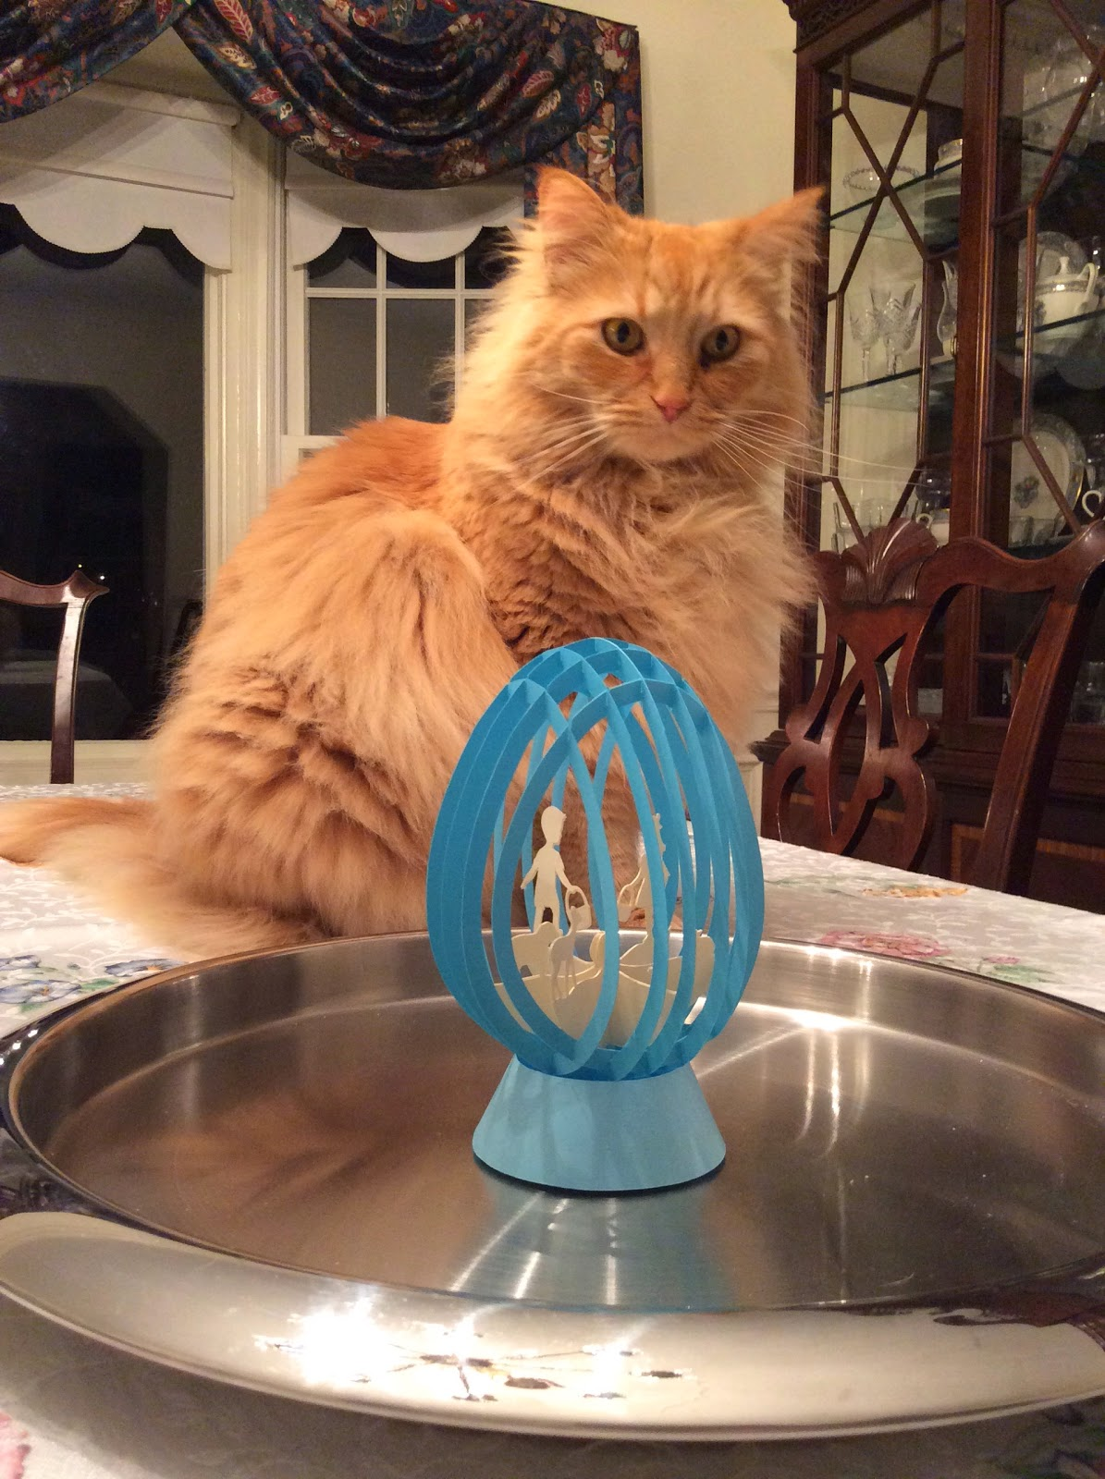

Of course, Marley loves the Easter egg snow globe.

The sliceform egg looks fantastic on its own if you would don't want the Easter egg hunt scenery.

The directions to make this sliceform are in a previous post.  
<http://papercraftetc.blogspot.com/2013/12/paper-snow-globe-sliceform-for.html>The Easter egg base is different than the previous version. You can use either base, if you would like, they are sized the same.

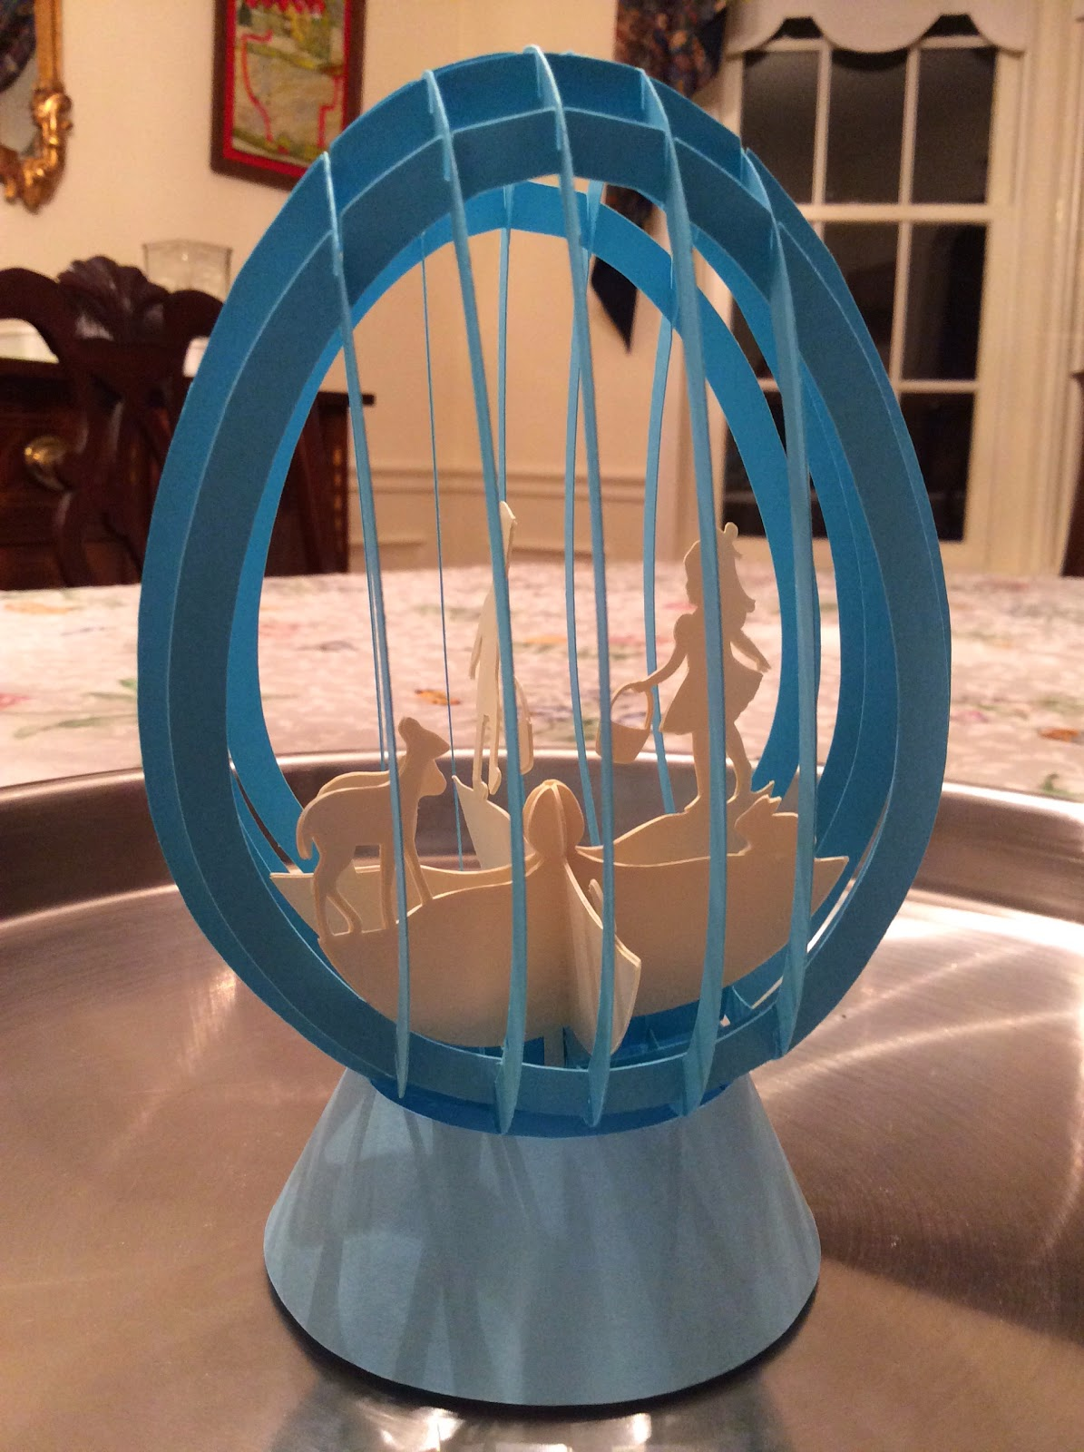

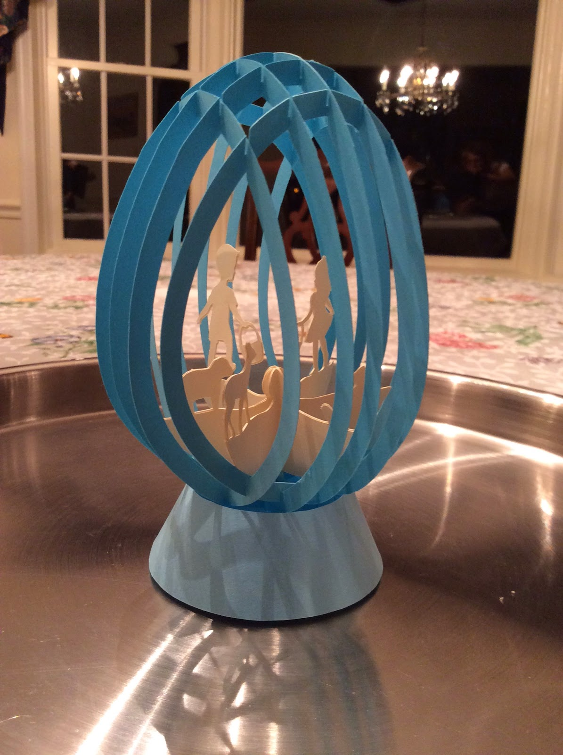

Happy Easter!